
Attendance Policy – Post 16

New document version | Revision date | Revised by | Section(s) revised & why | Comments | Next revision date
1.0 | 15.01.2026 | JG | New format & pathways | Removed and amended information | 15.01.2029

Introduction
Brian Jackson College provides a values rich environment, dedicated to upholding the values of the organisation – we provide a provision which is inclusive, empowering, caring, trusted and where all staff are approachable. We are determined to fulfil our mission statement to improve lives and inspire change.
This document demonstrates our shared commitment to improving the education of all our students and preparing them for the adult world and future destinations. The first responsibility of all members of staff will be to secure these values.

Our Vision at Post 16 is to ensure that:
- All students reach an appropriate destination
- All students leave with accredited courses which evidences their experience
- All students will have had the statutory support required to meet diagnosed SEN need

We believe that this document underlines the principles that effective management of attendance is best demonstrated as partnership, not just between learners and staff but also in partnership with the learners’ parents. We have a duty to safeguard and promote the rights and responsibilities of our students, and we believe that this is achieved in an environment in which all learners are known, valued, understood and guided
We aim to provide a just and fair environment, where every learner has an undeniable right to be treated fairly and in return is expected to respect others and treat them fairly.
The provision takes seriously its responsibility to protect and safeguard the interests of its students. We will provide opportunities for students to develop physically, socially, emotionally, spiritually and creatively and we recognise that healthy environments are those, which enhance self-esteem, encourage learning and promote and encourage respect for others.
The Pathways Model: A Relational Intervention for Attendance
Our Pathways Model offers a structured, staged approach to supporting pupils who are struggling with attendance. This model ensures interventions are:
- Tailored to each pupil’s story and context
- Relational in delivery, always beginning with listening and curiosity
- Empowering, helping the young person to be part of the solution
Key features of the Pathways Model include:
- Joint planning with pupils and families
- Attendance coaching and check-ins
- Transitional or part-time timetables (where needed)
- Home visits and community-based work
- Connection to therapeutic or pastoral support
- Ongoing reviews and adjustments as required
We believe that every young person wants to succeed, and when we understand the obstacles they face, we are better able to empower them with choices, connection, and hope.

Exceptional Circumstances
We recognise 100% attendance as being a huge achievement and one that needs significant reward and celebration! We do, however, recognise that in some cases, absence from school is unavoidable.
We define ‘exceptional circumstances’ as one-off events such a close family member being critically ill e.g., Grandparents, siblings. In which case we ask you to provide as much information as possible.
The academy considers each application for term-time absence individually. A leave of absence is granted entirely at the Head teachers discretion.
Valid reasons for authorised absence include:
- Illness and medical/dental appointments
- Religious observance where the day is exclusively set apart for religious observance by the religious body to which the learner’s parents belong
- Traveler learners travelling for occupational purposes, this covers Roma, English and Welsh Gypsies, Irish and Scottish Travelers, Showmen (fairground people) and Circus people, Bargees (occupational boat dwellers) and New Travelers.
Attendance Process – communicated with parents/carers
If your child is absent from the provision, you must telephone the college and notify them on the first day of absence before 9.00am and provide a reason for their absence.
- If we do not receive communication, you will receive a phone call from the college
- If we are unable to authorise the absence, then this will affect the attendance data and may result in a home visit

Learners’ attendance is monitored against our colour coded system:
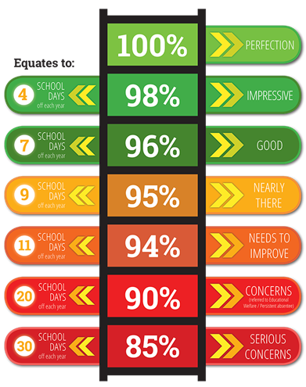
Rewards for excellent attendance
Maintaining an excellent attendance record is a brilliant achievement and one that we are delighted to reward and celebrate
Students who achieve their attendance target will be rewarded and celebrated during assemblies.
Punctuality
All post 16 learners are expected in school at 8.45 am. They will make their way to the SEAL area to meet key adults and have breakfast.
Lessons start at 9.15 and any student arriving after this time is late and the post 16 team will make contact home.
Students may leave the site during their lunch, this is at the discretion of the Head teacher and with parental consent.
For those students unable to access off site arrangements there will be lunches provided and they will have access to the SEAL social area and to a quiet area and the outdoor spaces.
Exclusions
Brian Jackson College Exclusions Policy works in accordance with the DfE guidance, “Exclusion from
Maintained Schools, Academies and Pupil Referral Units in England” updated September 2017. This policy is linked to the Positive Behaviour Policy, Equal Opportunities Policy and Care and Control Policy.
BJC recognises that to ensure a positive atmosphere based on a sense of community and shared values it may, on occasions, be necessary to suspend an individual or individuals either for a fixed period, or in rare circumstances, permanently.
Suspensions will only be resorted to when the school can demonstrate with adequate evidence that all reasonable steps have been taken and/or that the presence of the pupils is likely to be severely detrimental to his/herself, other pupils or staff. There may also be occasions when a short-term exclusion is appropriate because of the severity of unacceptable behaviour, to send a clear message to the pupil involved and others in the school. Suspensions will be followed with a back to college meeting to reintegrate the pupils with clear expectations and may include targets set in a behaviour contract. The provision will make all efforts to engage the parents/carers in this meeting on or before the first day the excluded pupil returns to school.
Purpose
- To maintain an environment where pupils can develop academically, morally and socially.
- To maintain the highest standards of behaviour.
- To maintain an environment where pupils feel safe and secure.
- To protect the well-being of all pupils and adults in the school.
This policy will be reviewed every 3 years or in response to any Dfe and Government changes in legislation.
Signed by Chair of Governors
Name: ______________________________________________________________________
Date: _______________________________________________________________________
Signature (electronic is accepted) ________________________________________________

